Governor Stirling Senior High School

Year 12 ATAR Physics

Semester One Examination 2019

Question/Answer Booklet

Student Name ________________________________________________

Teacher Name ________________________________________________

Time allowed for this paper

Reading time before commencing work: ten minutes

Working time: three hours

Materials required/recommended for this paper

*To be provided by the supervisor*

This Question/Answer booklet

Formulae and Data booklet

*To be provided by the candidate*

Standard items: pens (blue/black preferred), pencils (including coloured), sharpener, correction fluid/tape, eraser, ruler, highlighters

Special items: non-programmable calculators approved for use in this examination, drawing

templates, drawing compass and a protractor

Important note to candidates

No other items may be taken into the examination room. It is **your** responsibility to ensure that you do not have any unauthorised material. If you have any unauthorised material with you, hand it to the supervisor **before** reading any further.

|  |  |
| --- | --- |
| Score | |
| Section A |  |
| Section B |  |
| Section C |  |
| Total out of 180 |  |
| Percentage |  |

**Structure of this paper**

|  |  |  |  |  |  |
| --- | --- | --- | --- | --- | --- |
| Section | Number of questions available | Number of questions to be answered | Suggested working time (minutes) | Marks available | Percentage of examination |
| Section One  Short response | 13 | 13 | 55 | 58 | 32 |
| Section Two  Problem-solving | 6 | 6 | 85 | 86 | 48 |
| Section Three  Comprehension | 2 | 2 | 40 | 36 | 20 |
|  |  |  |  | **Total** | 100 |

**Instructions to candidates**

1. The rules for the conduct of the Western Australian external examinations are detailed in the *Year 12 Information Handbook 2019*. Sitting this examination implies that you agree to abide by these rules.
2. Write your answers in this Question/Answer booklet preferably using a blue/black pen.

Do not use erasable or gel pens.

1. You must be careful to confine your answers to the specific questions asked and to follow any instructions that are specific to a particular question.
2. When calculating or estimating answers, show all your working clearly. Your working should be in sufficient detail to allow your answers to be checked readily and for marks to be awarded for reasoning.

In calculations, give final answers to three significant figures and include appropriate units where applicable.

In estimates, give final answers to a maximum of two significant figures and include appropriate units where applicable.

1. Supplementary pages for planning/continuing your answers to questions are provided at the end of this Question/Answer booklet. If you use these pages to continue an answer, indicate at the original answer where the answer is continued, i.e. give the page number.
2. The Formulae and Data booklet is to be handed in with your Question/Answer

booklet.

|  |  |
| --- | --- |
| Section One: Short reponse | 32% (58 Marks) |

This section has **13** questions. Answer **all** questions. Write your answers in the spaces provided.

When calculating numerical answers, show your working or reasoning clearly. Give final answers

to **three** significant figures and include appropriate units where applicable.

When estimating numerical answers, show your working or reasoning clearly. Give final answers

to a maximum of **two** significant figures and include appropriate units where applicable.

Supplementary pages for planning/continuing your answers to questions are provided at the end of this Question/Answer booklet. If you use these pages to continue an answer, indicate at the original answer where the answer is continued, i.e. give the page number.

Suggested working time: 50 minutes.

____________________________________________________________________________

**Question 1**

The diagram below is of two asteroids in close proximity. The gravitational field in this region has also been included.

Which asteroid (left or right) has the larger mass? Explain your choice. **(3 marks)**

**Question 2 (7 marks)**

A 600 g block on a ramp inclined at 22.0o is accelerating down the ramp at 2.16 m s-2.

1. Draw a labelled vector diagram showing the relationship between the physical forces and the net force acting on the block. Include the angle in the diagram. (3 marks)
2. Calculate the frictional force acting on the block. (4 marks)

Answer: __________________N

**Question 3**

State whether the following statements are true or false for an ideal projectile, ignoring air resistance. If **false**, explain why. **(6 marks)**

|  |  |  |
| --- | --- | --- |
| **Statement** | **True or False?** | **If false, why?** |
| A projectile only accelerates towards the ground |  |  |
| The horizontal velocity of a projectile changes by 9.8 m s-1 each second |  |  |
| The velocity of all projectiles at their highest point is 0 m s-1 |  |  |
| The range of the projectile depends on the time in the air and the initial horizontal velocity |  |  |

**Question 4**

A car goes around a 32.0 m radius curve on a banked track that is inclined at 12.0o. A net force of 1790 N is applied to the car which keeps the car in a horizontal plane. Calculate the mass of the car. You must use a vector diagram to assist with your calculation. **(3 marks)**

Answer: _______________ kg

**Question 5**

Mars has 10.7% the mass of Earth and has a radius 53.2% of that of the Earth. **(4 marks)**

1. Calculate the gravitational field strength on the surface of Mars. (3 marks)

Answer: _____________ N kg-1

1. The parachute of a 56.0 kg NASA Mars rover fails to open as it descends to the surface of Mars. Ignoring air resistance, what is the acceleration of the rover close to the surface of Mars? (1 mark)

Answer: _____________ m s-2

**Question 6**

Ethan and Claire sit either side of the fulcrum of a see-saw, as shown in the diagram below. The plank of the see-saw has a 12.5 kg centre of mass located at the fulcrum.

Ethan

Claire

Ethan has a 32.0 kg mass and Claire a 28.0 kg mass. Claire sits 1.23 times further from the fulcrum than Ethan. One of the children has their feet on the floor, pushing on it so that the see-saw is in equilibrium. Which child is touching the floor and what is the magnitude of this pushing force? **(5 marks)**

Answer:__________________N

**Question 7**

Two spheres with equal but opposite electric charge are placed 7.55 cm apart and experience 5.11 × 10-4 N of attractive force. Calculate the magnitude of the electric charge on each sphere. **(3 marks)**

Answer: _________________ C

**Question 8**

Calculate the range of a projectile fired at 5.60 m s-1, launched from a height of 12.5 m above the ground and fired at 22.0o below the horizontal plane. Ignore air resistance. **(5 marks)**

Answer: _______________m

**Question 9 (6 marks)**

Two identical wires are arranged so they are parallel and each carries 1.32 A. The magnetic flux density exactly half way between the wires is 30.0 µT – only the wires are responsible for this magnetic field.

1. Are the wires carrying the current in the same direction or in opposite directions?

Justify your choice with the aid of a diagram. (3 marks)

**Diagram**

1. Calculate the distance halfway between both wires. (3 marks)

Answer: __________________ m

**Question 10**

A hump back bridge is constructed so it has a radius of 50.0 m. What is the maximum speed a motorcyclist can travel across the top of the bridge without lifting off the bridge’? **(3 marks)**



Answer: ______________m s-1

**Question 11**

Jacob is freewheeling his mountain bike down a hillside track composed of gravel and sand. The bike remains stable when Jacob is going in a straight line but when he reaches a curved section of the track his wheels slide away and he crashes.

Explain why Jacob is more likely to crash when going into a curved section of the track.

**(3 marks)**

**Question 12**

A canoeist paddles at a constant velocity from one bank directly across a river which is flowing at 3.50 m s-1. If the canoeist is travelling at 1.50 m s-1 and the river is 35.0 m wide. Calculate the displacement when he reaches the opposite bank of the river? **(4 marks)**

Answer: __________________m Direction: ______________________________________

**Question 13 (6 marks)**

An electric field is used to accelerate an electron into a uniform perpendicular magnetic field of strength 230 μT. It follows a semi-circular path through the magnetic field of radius 350 mm, as illustrated at right.

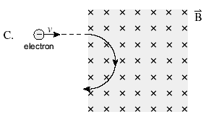

(a) Calculate the speed needed for the electron to follow the semi-circular path. (3 marks)

Answer: __________________m s-1

(b) Determine the potential difference through which the electron was accelerated (before reaching the magnetic field) in order to have this speed. (3 marks)

Answer: _________________ V

**End of Section One**

|  |  |
| --- | --- |
| **Section Two: Problem-solving** | **48%(86 Marks)** |

This section has **six** questions. Answer **all** questions. Write your answers in the spaces provided.

When calculating numerical answers, show your working or reasoning clearly. Give final answers to **three** significant figures and include appropriate units where applicable.

When estimating numerical answers, show your working or reasoning clearly. Give final answers to a maximum of **two** significant figures and include appropriate units where applicable.

Supplementary pages for planning/continuing your answers to questions are provided at the end of this Question/Answer booklet. If you use these pages to continue an answer, indicate at the original answer where the answer is continued, i.e. give the page number.

Suggested working time: 90 minutes.

____________________________________________________________________________

**Question 14 (10 marks)**

A 20.0 cm long conducting rod forms a circuit with a 3.00 V battery, connected via some loose wires which dangle freely from either end of the rod. The rod is also tethered to a magnet via a pair of strings and can swing freely. Another magnet sits below the rod to create a uniform 0.500 T field. The rod’s uniform distributed mass is 0.0900 kg and has a 2.00 Ω resistance. You may assume the mass of the string and loose wires are negligible and the resistance of the loose wires is negligible.

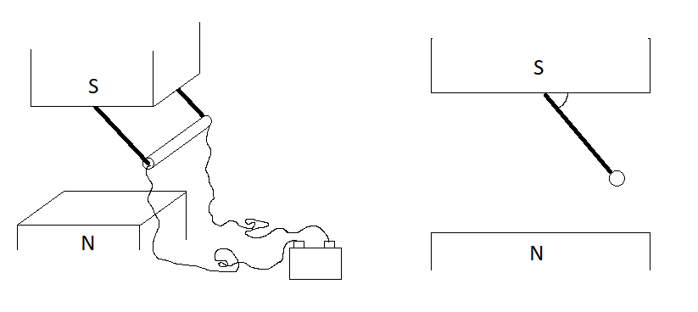

String

Loose wire

Rod

Simplified 2D view

Detailed View

When everything is connected, the rod swings to one side and remains in the position shown

in the simplified 2D view.

1. By drawing a positive and negative sign, label the polarity of the battery in the diagram above. (1 mark)
2. Calculate the current through the rod. (1 mark)

Answer: __________________ A

**Question 14 (continued)**

1. Calculate the magnetic force acting on the rod. (2 marks)

Answer: _______________ N

1. Calculate the tension in one of the pieces of string. (4 marks)

Answer: _______________ N

1. Calculate the angle the string makes with the magnet face ( in diagram). (2 marks)

Answer: ____________ degrees

**Question 15 (17 marks)**

A satellite galaxy is a galaxy that is bound to a parent galaxy. Just as a star is the dominant source of gravitational field within a solar system, causing satellite planets to orbit around it, a large parent galaxy is the dominant source of a gravitational field, causing smaller satellite galaxies to orbit around it. The Canis Major Dwarf Galaxy (CMDG) is proposed to be a satellite galaxy of the Milky Way. The CMDG has an average distance of 4.84 × 1017 km from the centre of the Milky Way and contains 1 billion stars. This makes the CMDG much smaller than the Milky Way which contains 250 billion stars. For these questions, you may assume the mass of each galaxy is a point mass at its centre and that the mass of our Sun is an average star’s mass.

1. Calculate the gravitational force that the Milky Way places on the CMDG.(4 marks)

Answer: _________________ N

1. Calculate the velocity of the CMDG if it were to maintain a circular orbit about the Milky Way. If you could not obtain an answer to part (a) you may use 2.75 × 1029 N.(3 marks)

Answer: _______________ m s-1

**Question 15 (continued)**

(c ) The Sun lies on the line between the centre of the Milky Way and the CMDG. The CMDG attracts the Sun with a force 0.350 % that of the Milky Way. Calculate the distance of the Sun from the centre of the Milky Way. (7 marks)

Answer: _______________m

(d) Neither the Milky Way nor the CMDG is a point mass – they are each a distributed mass of stars with large amounts of empty space. Which galaxy (Milky Way or CMDG) being modelled as a distributed mass would have the biggest impact on your answer to part (c)? Justify your response. (3 marks)

**Question 16 (15 marks)**

A junior engineer is tasked with analysing the safety of a new scaffold, designed to extend over surfaces that could not hold scaffolding. Platform AB is 12.5 kg and 2.00 m long. Platform BC is 6.20 kg and is 0.800 m long. A mounting bracket is located at point A which secures the platform to the ground and is free to rotate. A 75.0 kg worker stands on point C. A strut helps support the platforms by taking on a compression force, located 1.80 m along platform AB. The strut is rated to hold a maximum of 1.40 kN.

**A**

**B**

**C**

20.00

Support Strut

Mounting Bracket

Ground

1. Assuming the force of the strut acts vertically upwards onto AB, will the strut be able

to support the platform and worker? Justify your answer. (5 marks)

**Question 16 (continued)**

1. Calculate the force the mounting bracket applies to the platform. Include the direction of this force. If you could not obtain an answer to part (a), you may use 1.31 × 103 N.

(4 marks)

Force: _________________ N Direction: __________________

1. If the strut was moved closer to point A, while still remaining vertical, explain what would happen to the force in the strut. (2 marks)

1. The junior engineer suggests making platform BC longer and thinner – his argument being the mass of platform BC would stay the same, so the strut could still hold the weight of the workers and they could reach further. Explain whether the junior engineer’s idea is physically sound. (4 marks)

**Question 17 (17 marks)**

A railgun is a device that utilises electromagnetic forces to accelerate and launch high speed projectiles. This has potential uses in weapons as well as launching objects into space. A railgun has two conducting rails (hence the name), aligned parallel like railway tracks. An armature (the projectile) can slide along these rails. A current is passed down the bottom rail, through the armature and returns via the top rail.

Rail

Armature

I

I

The current passing through the rails produces a magnetic field into the space between the rails. The magnetic field of each rail contributes to create a net flux between the rails. The armature carries the same current as the rails but it flows perpendicular to the magnetic field produced by the rails. The magnitude of the magnetic force on the armature depends on the square of the current. Other factors such as the distance between the rails and magnetic permeability of air can be combined into one scaling factor, , such that the force is given by:

* is the force on the armature in newtons (N)
* is the inductance per unit length in henries per metre (H m-1)
* is the current in the railgun circuit in amperes (A)

1. State the direction of the magnetic force acting on the armature in the diagram of the railgun shown above. (1 mark)

Direction:

1. By referring to formulae from the Formula and Data Booklet, justify why the force is proportional to the square of the current. (3 marks)

**Question 17 (continued)**

NASA testing obtained the following measurements for how force varied with current for a

prototype railgun.

|  |  |  |  |
| --- | --- | --- | --- |
| **Current (A)** | **Force (N)** | **Force uncertainty (N)** |  |
| 3.0 | 2.1 |  |  |
| 5.0 | 6.1 |  |  |
| 7.0 | 11.5 |  |  |
| 8.0 | 17.1 |  |  |
| 9.0 | 19.1 |  |  |

1. NASA estimates the force measurements have an 8% uncertainty. Complete the absolute force uncertainty column in the table above. (1 mark)
2. Produce a line graph for NASA’s experiment which includes error bars on the grid provided. You must manipulate the data such that the graph shows a linear relationship between the relevant variables of NASA’s experiment. You may use the empty column in the table for additional working. (5 marks)

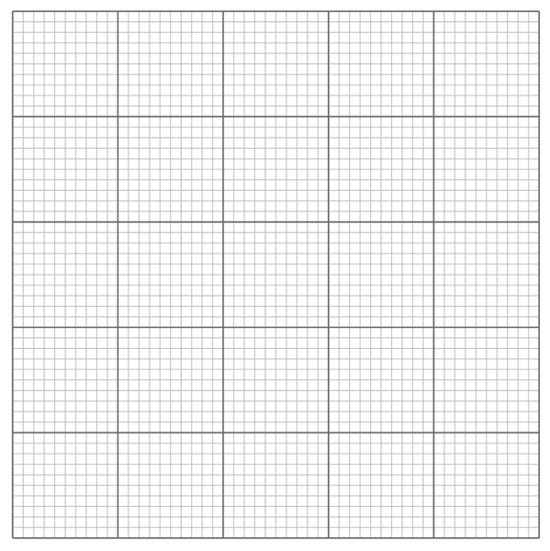

**Question 17 (continued)**

A spare grid is provided on the end of this Question/Answer booklet. If you need to use it, cross out this attempt and clearly indicate that you have redrawn it on the spare page.

1. Calculate the gradient of your line of best fit from the graph. Include units, construction lines and show your working. (4 marks)

Answer: __________________ Unit:______________

1. Using the gradient, determine the inductance per unit length () of the railgun used in this experiment. (3 marks)

Answer: H m-1

**Question 18 (14 marks)**

A student designed and built a motor made from 200 windings of insulated copper wire, formed into a 6.00 cm x 9.00 cm rectangular coil. The student attaches a 12.0 V car battery to the coil via a split ring commutator and conducting brushes. A pair of strong rare earth magnets provided an external magnetic field. The students were delighted that their motor spun at 1200 rpm.

1. Explain the interaction between the current in the coil and the magnets that causes a motor’s coil to spin. (4 marks)

1. Explain the purpose of the commutator and brushes. (4 marks)

**Question 18 (continued)**

1. The motor coil carries 1.50 A current when first starting to rotate. Calculate the total

torque produced by this motor during start-up if the magnetic flux density produced by a pair of rare earth magnets in the region of the motor coil is 0.125 T. (6 marks)

Answer:

**Question 19 (13 marks)**

A laser printer works on principles of electric fields. Dry and positively charged toner flakes (the printer ink) are attracted to a negatively charged drum. The paper is fed underneath the drum as it rotates and the toner flakes drop from the drum to the paper. The paper is able to grab hold of the toner flakes as the paper is even more negatively charged than the drum.

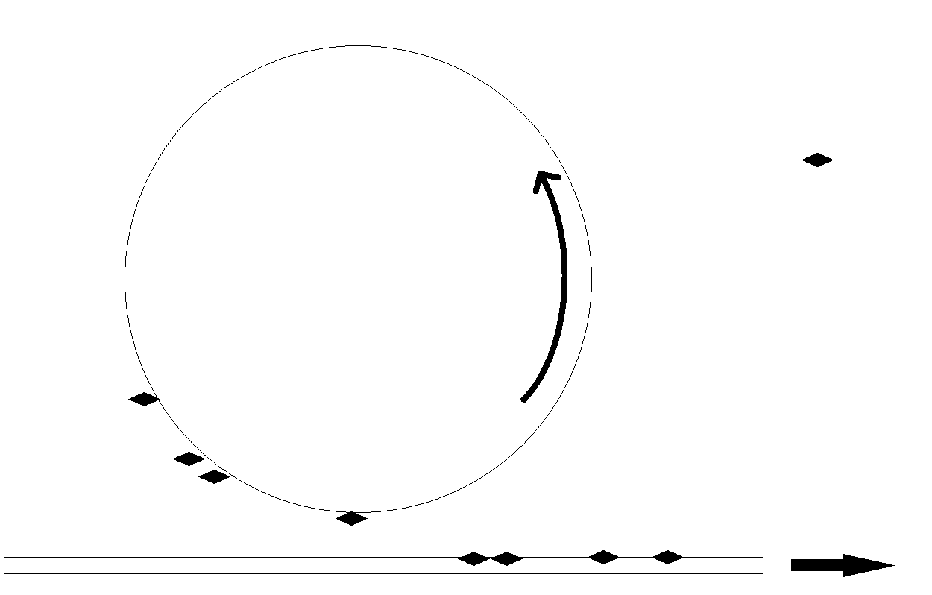

2.25 cm

50.0 µm

0.750 m s-1

Toner flakes

Paper

Rotating Drum

The diagram is not to scale and exaggerates elements of the design to make it clear. The drum is 2.25 cm in radius. The minimum distance between the drum and paper is 50.0 µm. Each flake of toner is 1.89 × 10-8 g. The paper moves past the drum at 0.750 m s-1 and the drum rotates at the same rate so that it can print clear images onto the paper as they move past each other.

1. The drum has a -3.00 V potential and the paper has a -7.00 V potential. Estimate the electric field strength in the space in between the paper and closest point on the drum. Include a direction in your answer. (3 marks)

Electric Field: _______________ V m-1 Direction: ________________

**Question 19 (continued)**

1. Describe why your previous answer is only an estimate. (2 marks)

1. A single toner flake carries a positive 5.60 nC. By comparing the magnitude of the electrical force and gravitational force acting on the toner, explain whether gravitational forces need to be considered in the design of the laser printer. (3 marks)

**Question 19 (continued)**

1. During a malfunction where paper is no longer fed in, but the drum keeps spinning at its operating speed, the electric field keeping the flakes attached to the drum is

9.91×10-2 N C-1. Determine whether the toner flakes would remain attached to the drum during the malfunction. (5 marks)

**End of Section Two**

|  |  |
| --- | --- |
| **Section Three: Comprehension** | **20% (36 Marks)** |

This section has **two** questions. You must answer **both** questions. Write your answers in the spaces provided.

When calculating numerical answers, show your working or reasoning clearly. Give final answers to **three** significant figures and include appropriate units where applicable.

When estimating numerical answers, show your working or reasoning clearly. Give final answers to a maximum of **two** significant figures and include appropriate units where applicable.

Supplementary pages for planning/continuing your answers to questions are provided at the end of this Question/Answer booklet. If you use these pages to continue an answer, indicate at the original answer where the answer is continued, i.e. give the page number.

Suggested working time: 40 minutes.

**Question 20 (18 marks)**

**A space elevator for Earth**

As of 2018, thousands of objects have been launched into space. This may make it sound like we have mastered space travel but there are lots of opportunity for innovation. In 2018, the cost to transfer objects to space sits around 40 000 AUD per kilogram, making spaceflight prohibitively expensive for all but the wealthiest nations and corporations. One means of reducing the cost is to do away with using combustion of fuel to provide the energy to escape the gravitational pull of the Earth and to replace it with….. an elevator.

Sound bizarre? Da Vinci invented the concept of the armoured tank, helicopter and even robots well before society had the materials to realise them – these were bizarre ideas in his time. The same is true of the space elevator. The idea and concept are sound and has been around since 19th Century; we just lack the right materials to make it happen.

The space elevator requires a cable, anchored at the equator, to extend out beyond the geostationary orbit of the Earth and a counterweight of large mass attached at the end. To reach an orbital altitude, an elevator can move along the cable via mechanical means.

Geostationary Orbit

Earth

Cable

Counterweight

The section of cable below the geostationary orbit would fall to Earth under the influence of gravity. Beyond the geostationary orbital radius the gravity field is weaker and the cable, with added counterweight, keeps the cable held up, under tension.

In this course you have been exposed to the concept of a centripetal force. You may have also been exposed to the concept of a centrifugal force – an apparent force that pushes an object outside of its circular path. The centrifugal force is also called a fictitious force or ‘inertial force’ because it is only felt in the frame of the rotating object, due to the effects of inertia, and is not due to any physical force. A good example is being a standing passenger on a bus as it turns a corner – you feel like you are being pushed away from the centre of rotation. This sensation of a pushing force is due to your inertia, not an actual force. Even though not a physical force, calculations can be performed which account for the centrifugal force. After all, when in the right frame, whether due to inertia or not, you can argue that you will be ‘pushed’ into the side of the bus as it turns, fictitious force or not. The apparent gravitational field is due to a combination of the gravitational field and the centrifugal acceleration:

You should be familiar with the first term in the above expression. The second term is the inertial(centrifugal) acceleration where is the rotation speed in radians per second (9.32 × 10-5 radians per second for Earth) and is the radius in metres. At some point along the cable, the two terms are equal and opposite. At this point the apparent gravitational field is zero and any object on the cable would not put weight onto the cable. Locations above this point experience smaller gravity and larger inertial acceleration, thus any cable material further than this point will be pulled out by the inertial force more than it is pulled in by the gravitational force.

To realise a space elevator, we need a material that has ten times as much tensile strength as the strongest, lightest materials already well developed on Earth. Carbon nanotubes and diamond nanothreads are possibly suitable candidates; more research is required.

1. State one obstacle of modern space flight. (1 mark)

1. Describe the basic structure of a space elevator. (2 marks)

**Question 20 (continued)**

1. Describe one obstacle from the article that needs to be overcome to build a working space elevator and what the possible solution is. (3 marks)

1. State the two forces acting on the space elevator cable, including the direction they act in. (4 marks)

Force 1: ___________________ Direction _______________________

Force 2: ____________________ Direction _______________________

1. Explain how the use of a counterweight allows a shorter cable to be used than if designed without a counterweight. (4 marks)

**Question 20 (continued)**

1. The geostationary orbit around Earth occurs at an orbital radius of 35,800 km.
2. Calculate the apparent gravitational field at this point. (3 marks)

Answer: N kg-1

1. State what happens to the value of the apparent gravitational field as the distance is increased beyond the geostationary orbit. (1 mark)

**Question 21 (18 marks)**

**Model Rocket**

A group of students built and used a model rocket to investigate force and motion. The rocket had a total mass of 250.0 g and was powered by a stiff spring which could be compressed by 25.0 cm. A parachute inside the rocket was programmed to open after the rocket had reached its maximum height. The diagrams below show how the rocket was launched and how the parachute deployed for the descent.



When it is launched, the rocket leaves the spring and the spring returns to its original length. The compression in the spring provides the force necessary to launch the rocket and is given by F = k x where F is the force in newtons, k is the proportionality constant and x is the extension or compression of the spring in metres.

The graph below shows the force – compression characteristic of the spring.



By referring to the graph the energy can be calculated for a compression of 0.25 m:

The area under the curve is equivalent to the energy stored in the spring = ½ (1000 x 0.25) = 125 J

**Question 21 (continued)**

(a) Calculate the rocket’s speed as it leaves the spring. (2 marks)

Answer: _______________m s-1

(b) What force(s) act on the rocket immediately after it leaves the spring? (2 marks)

(c) If the rocket took 2.90 s to reach its maximum vertical height, calculate the uniform

deceleration of the rocket. (2 marks)

Answer: ______________m s-2

(d) Neglecting air resistance, calculate the maximum height the rocket could reach.

(2 marks)

Answer: __________________ m

**Question 21 (continued)**

(e) In fact the rocket DID experience air resistance. Is the value for the uniform

deceleration calculated in Question (c) consistent with the rocket experiencing air

resistance? Explain your answer. (2 marks)

(f) Using the group’s results and your previous calculations, calculate the average

retarding force due to air resistance on the rocket. (2 marks)

Answer: __________________________N

Upon reaching its maximum height, the rocket begins to fall vertically to the ground. Soon after the start of its descent, the parachute opens and the rocket slowly returns to the ground.

A velocity – time graph of the descent is shown below.



(g) Use the graph to estimate the time it took for the parachute to open. Explain your

answer. (3 marks)

As it descends, the air resistance on the rocket, is small compared to the retarding force of the parachute. The graph below shows how the combined rocket /parachute retarding force varies with time as they fall.



(h) Use the graph to determine the acceleration of the rocket 3 s after it begins its descent. (3 marks)

Answer: ______________m s-2

**END OF EXAMINATION**

Supplementary page

Question number: _________________

Supplementary page

Question number: _________________

Supplementary page

Question number: _________________

Spare grid

